**Exercise 2:** Suppose we have a computer that contains a folder called “family” in which the standard users can create files, but only administrators can delete them. We want to share the folder with “Full control” permissions for standard users and administrators (or the maximum level of permissions that we are able to assign).

In addition, we can grant access to the folder for users that do not have an account. The permissions will be “Read-only” in this case.

Create the shared folder according to the criteria above

---

For this exercise we will need to disable the “Password protected sharing”. We can do it by accessing “Network and Sharing Center” and “Advanced sharing settings”.

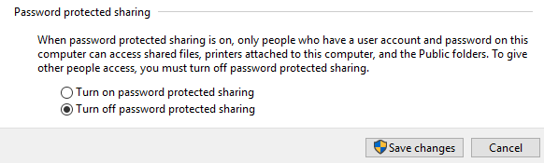

Now we need to create the required folder and set its permissions. We will need to add permissions for the following special identities: “Users” and “Everyone”.

To set local permissions we go to Properties → Security → Advanced Security (and to add those special identities we need to click “Add” and follow the steps on the image below).

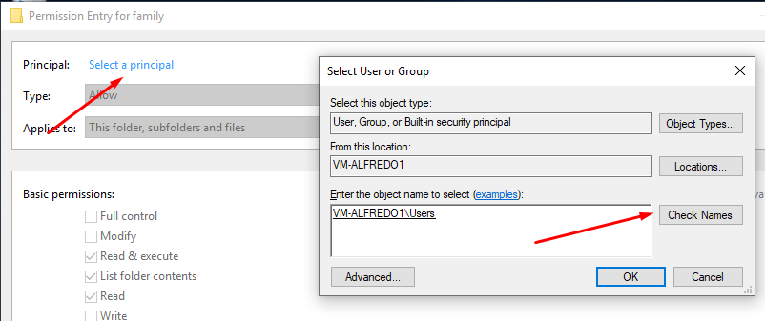

After that, we can set the permissions we need and the final result will be more or less like this:

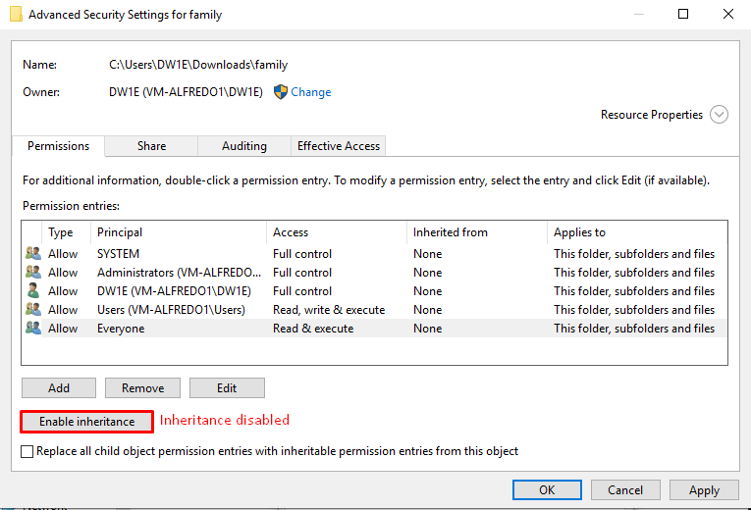

**CORRECTION:** Administrators are not permitted in shared folders due to security reasons, so Sergio sets “Modify” permissions for the Administrator and his main user (Administrator too).

Now we go for the sharing permissions. We first need to check the “Share this folder” option and then click on “Permissions”. Once there, we can add

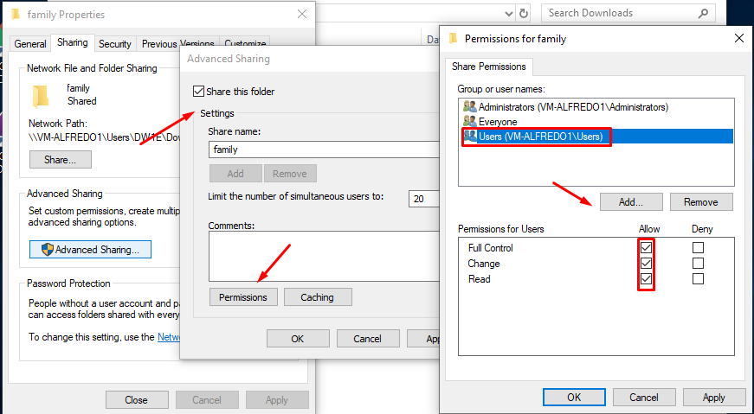

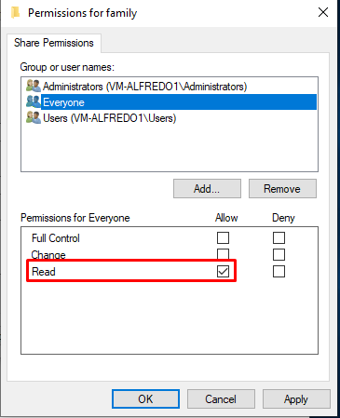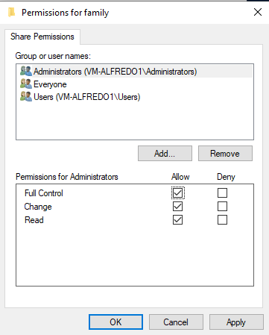

This is what we see when we try to access:

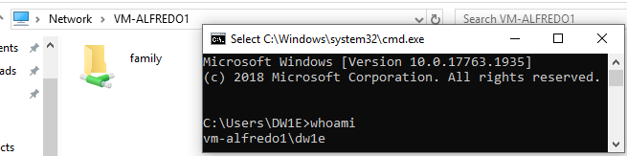

This is what we see when we try to access from another machine:

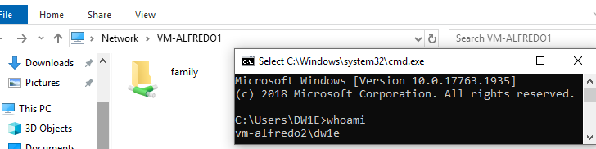

No password or credentials are required because of the permissions set for Everyone, Administrators and Users (they all let everyone to, at least, read the file).

**CORRECTION**: There are missing steps. Sergio also adds an image, with which it explains that the only way to access with different credentials is going to “Map Network Drive”, adding the shared folder path and enabling the option “Connect using different credentials”.

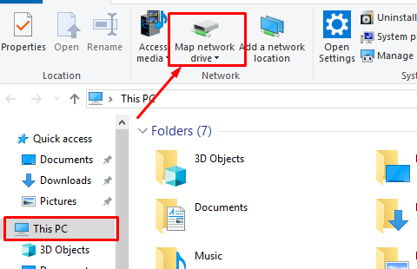

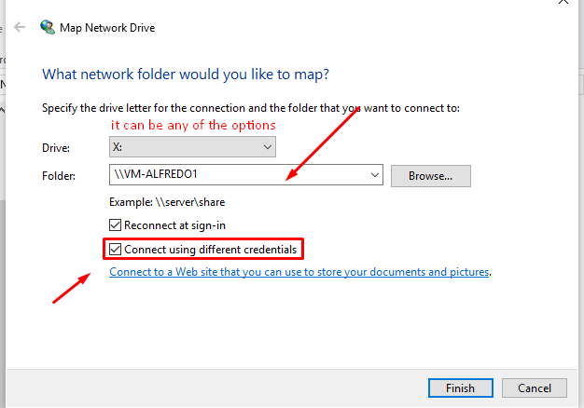

**ALFREDO PUERTA GALLEGO DW1E**